- All the participating schools must attach the proof of payment of Annual Sports fee 2012 – 13 along with entry proforma.
- The organizing schools will not accept any entry without the above information.
- The entries / eligibility forms must reach us before 31ST August, 2012 by Courier / Speed Post.

The competition will be conducted according to the rules and regulations of the Swimming Federation of India (SFI) unless otherwise modified by CBSE Board, New Delhi.

(i) In under 12 year’s age group, a swimmer can participate in maximum three individual events and in relays.
(ii) In under 14 year’s age group, a swimmer can participate in maximum four individual events and in relays.
(iii) In under 16 & 19 years age group, a swimmer can participate in maximum five individual events and in relays.
- Every school will be entitled to enter only one competitor in each of the following events.
- No team will be allowed to participate without a Team Manager or Coach.
- Each school will send one staff member, as the manager, with the team who will be responsible for the conduct of the participants. If girls are participating, a lady staff member should accompany them.
- The Team Manager/ Coach is requested to ensure that the teams maintain strict discipline in the pool and within the campus.
- If there is any absent or withdrawal please informs us in managers meeting .Otherwise a fine of Rs.1000 will be payable .
- In case there are less than four swimmers present for a particular event, it will be conducted and the swimmer will be awarded the medals and the merit certificate but the points will not be included for awarding individual or team championship. The name of the first and second winning swimmers will be forwarded for participation in National level.
- The decision of the referee on all technical aspects will be final.
- Protest regarding any event should be made within 1 hour of the completion of the event, duly accompanied by a fee of Rs. 1000/-(One thousand only) to the organizing secretary which will be refunded if the protest is upheld.
- A separate prize will be given to the individual champion for boys & girls section, in all the age categories. For the deciding the individual champion, the performance in the individual events and individual medley will be taken into consideration.
- The championship will be decided separately in boys & girls section. The points shall be awarded to the team have according to the point systems as per the following criteria as adopted by S.F.I.
Position | Individual Events | Relays
1st Place | 07 Points | 14 Points
2nd Place | 05 Points | 10 Points
3rd Place | 04 Points | 08 Points
4th Place | 03 Points | 06 Points
5th Place | 02 Points | 04 Points
6th Place | 01 Points | 02 Points

- A prize will be given to the school scoring ‘total maximum points’ and will be declared as ‘over all champion’.

- If all the five members of the relay team have registered their name in this eligibility proforma and have attended the meet irrespective of who swims, they will be awarded medals and certificates if they win.
- Each participant will be provided with participation certificate by CBSE Board.
- All the first three position winning swimmers will be awarded merit certificates by CBSE Board.
- Swimming costume is compulsory.
- Heavy fine will be levied if damage is caused to the school property.
- Smoking and using Alcohols is strictly prohibited inside the organizing school campus.
- On arrival at the organizing school, the teams have to report to the Organizing Secretary
Ms. SAMEEXA AWASTHI(09451286878).
- Participation in March Past is compulsory failing which their right to participate will be forfeited.
- Under any circumstances on the spot entry and late entry will not be entertained.
- The last date for receiving detailed entry forms/ documents/ travels forms is on or before 31ST August, 2012.

- Each team must bring 02 school flags, one would be required for the march past and the other would be hoisted on the inaugural day at the venue.
- All the Participating teams (swimmers) must have their own ‘School Identity Card’ giving all the details (Name, Date of Birth, Class, and Admission No. , Events, and Photographs) duly attested by the head of the institution.
- Attach photocopy of class X passing mark sheet/ class IX registration certificate of the participant with the Performa.
- Each team will have to produce a group photo of the team with Team Coach, Manager and the Principal of the school which should be duly attested by the Principal on the back side.
- Please ensure that the names of the participants are written legibly without spelling mistakes.

Lodging & Boarding
- Accommodation and arrangement for food will be made inside the organizing school campus. An amount of Rs. 250/- (Two hundred and fifthy only) per head/ day has to be paid towards catering expenses. The Team Manager has to purchase the coupons from the organizing school in advance on the day of arrival.
- Meals coupons once purchased will be non-refundable.
- Dormitories will be provided for participants, Managers and Coach inside the school campus. Parents will have to stay outside the school campus on their own.
- The team is expected to carry their own bedding which comprises of bed sheets, pillows, toiletries and other personal requirements.
- School will not be responsible for any kind of loss of valuables including gold, ornaments, mobile phones, cameras and money.
- School will provide separate accommodation for boys & girls in the school premises. The Manager / Coach of the respective team will stay with the participants.

- Under 12 years: Born on or after 01.01.2001
- Under 14 years: Born on or after 01.01.1999
- Under 16 years: Born on or after 01.01.1997
- Under 19 years: Born on or after 01.01.1994
- A player shall be under 12, 14, 16 & 19 years of age on 31 Dec 2012.

- A Performa for your travel plan is enclosed with this letter.
- Teams are requested to inform the exact date & time of arrival/departure of buses and trains to enable the organizers to receive/dispatch the team at Railway Stations. If the teams do not inform their travel plan, the school will not be able to arrange transport from KANPUR Central to School and back.
- Kanpur Central Railway Station (which is 15 KM from The Jain International School)
- Transport will be provided from Kanpur Central Railway Station / Jhakerkati Bus Depot on 25th September, 2012 and 29TH September, 2012 at arrival and departure only.
- For any clarification regarding Transport kindly contact Mr. Tejendra veer Sharma (09336660467).

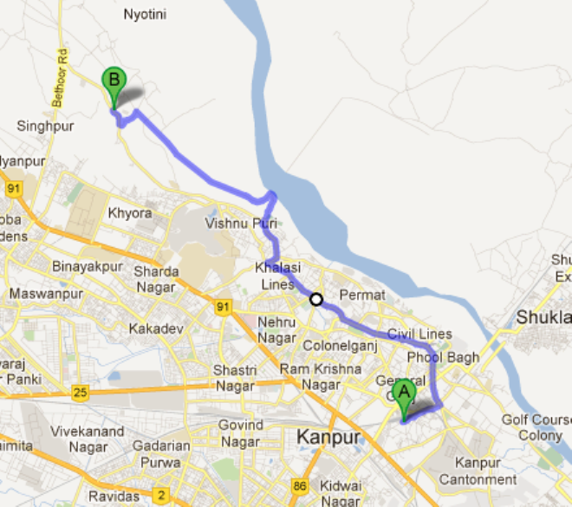

POINT A – KANPUR CENTRAL RAILWAY SATION
POINT B – THE JAIN INTERNATIONAL SCHOOL KANPUR

Under-12 years |  | Under-14 years |  | Under-16 years |  | Under-19 years
1 | 50 M (F/S) | 1 | 50 M (F/S) | 1 | 50 M (F/S) | 1 | 50 M (F/S)
2 | 100 M (F/S) | 2 | 100 M (F/S) | 2 | 100 M (F/S) | 2 | 100 M (F/S)
3 | 50 M (B/S) | 3 | 200 M (F/S)* | 3 | 200 M (F/S)* | 3 | 200 M (F/S)*
4 | 50 M (BR/S) | 4 | 50 M (B/S) | 4 | 400 M (F/S)* | 4 | 400 M (F/S)*
5 | 50 M (BF/S) | 5 | 100 M (B/S) | 5 | 800 M (F/S)* | 5 | 800 M (F/S)GIRL*
6 | 200 M (IM)* | 6 | 50 M (BR/S) | 6 | 50 M (B/S) | 6 | 1500 M (F/S)BOY*
7 | 4X50 M (FS/R) | 7 | 100 M (BR/S) | 7 | 100 M (B/S) | 7 | 50 M (B/S)
8 | 4X50 M (MR) | 8 | 50 M (BF/S) | 8 | 200 M (B/S)* | 8 | 100 M (B/S)
 |  | 9 | 100 M (BF/S) | 9 | 50 M (BR/S) | 9 | 200 M (B/S)*
 |  | 10 | 200 M (IM)* | 10 | 100 M (BR/S) | 10 | 50 M (BR/S)
 |  | 11 | 4X100 M (FS/R) | 11 | 200 M (BR/S)* | 11 | 100 M (BR/S)
 |  | 12 | 4X100 M (MR) | 12 | 50 M (BF/S) | 12 | 200 M (BR/S)*
 |  |  |  | 13 | 100 M (BF/S) | 13 | 50 M (BF/S)
 |  |  |  | 14 | 200 M (BF/S)* | 14 | 100 M (BF/S)
 |  |  |  | 15 | 200 M (IM)* | 15 | 200 M (BF/S)*
 |  |  |  | 16 | 4X100 M (FS/R) | 16 | 200 M (IM)*
 |  |  |  | 17 | 4X100 M (MR) | 17 | 400 M (IM)*
 |  |  |  |  |  | 18 | 4X100 M (FS/R)
 |  |  |  |  |  | 19 | 4X100 M (MR)
Note: -
F/S – Free Style B/S – Back Stroke BR/S – Breast Stroke BF/S – Butterfly Stroke
IM – Individual Medley FS/R – Free Style Relay MR – Medley Relay
- Events marked indicated using an asterix (*) will be conducted on time trial basis. It would mean that every swimmer in these events will get only one chance, and the final position in these events will be determined on the basis of time recorded in different heats.

